EXPERIMENT 2: OPEN SOURCE INTELLIGENCE GATHERING USING OSRF FRAME WORK

COMMAND : usufy.py -n (name) -p Instagram facebook twitter

2.1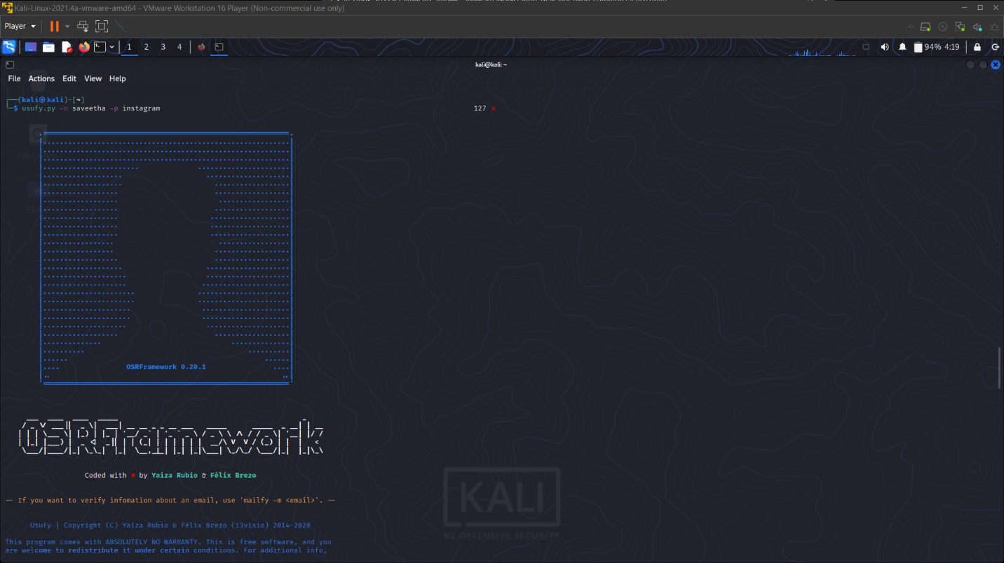

2.2